

**National Capital Region Drug Trend Mapping System**

**Detailed Design**

**Prepared For**

**Sgt. Pat Poitevin, RCMP**

**Professor Edmund Strange**

|  |  |
| --- | --- |
| Prepared By: | D. Marcantonio, Project Leader |
|  | L. Desjardins |
|  | E. Dube |
|  | T. Ferch |
|  | L. Morin |
|  | S. Reece |

Submission Date: January 31st, 2010

**List of Figures** Page

1. Context Diagram 4
2. Overview EERD 10
3. Account EERD 11
4. AccountZones EERD 12
5. Authorization EERD 12
6. Drug EERD 13
7. DrugAlias EERD 14
8. DrugColor EERD 14
9. DrugDescription 15
10. DrugEffect EERD 15
11. DrugSideEffect EERD 16
12. DrugStamp EERD 16
13. DrugType EERD 17
14. Entry EERD 17
15. EntryEffect EERD 19
16. EntrySideEffect EERD 19
17. Message EERD 20
18. Organization EERD 21
19. Zone EERD 21
20. Overview CD 22
21. ContributorsPage CD 23
22. EditAccountPage CD 23
23. EditEntryPage CD 24
24. LoginPage CD 25
25. MasterPage CD 26
26. MessagesPage CD 27
27. ReportsPage CD 29
28. RequestMebershipPage CD 31
29. WelcomePage CD 32
30. ZonesPage CD 33
31. Contributors HCI 34
32. Contributors Administrator HCI 35
33. Edit Account HCI 36
34. Edit Entry HCI 37
35. Edit Settings HCI 39
36. Entries HCI 40
37. Entries Administator HCI 41
38. Login HCI 42
39. Message Centre HCI 43
40. New Entry HCI 44
41. Report Preliminary HCI 45
42. Request Membership HCI 47
43. Welcome HCI 48
44. Zones HCI 50

**List of Tables** Page

1. Useful Requirements 5
2. Desirable Requirements 7

**Table of Contents** Page

Contact Information 1

1 Introduction 2

1.1 Goals and Objectives 2

1.2 Statement of Scope 2

1.2.1 Project Initialization 2

1.2.1.1 Purpose of the Project 2

1.2.1.2 Users of the Product 2

1.2.2 Application and Development Environments 3

1.2.2.1 Application Environment of the Purposed System 3

1.2.2.2 Development Environment of the Purposed System 3

1.2.3 Functional Requirements 4

1.2.3.1 The Scope of the Work 4

1.2.3.2 Functions Provided by the Project 5

1.2.4 Non-Functional Requirements 7

1.2.4.1 Mandated Constraints 7

1.2.4.2 Look and Feel Requirements 7

1.2.4.3 Usability Requirements 7

1.2.4.4 Personalization Requirements 8

1.2.4.5 Ease of Learning Requirements 8

1.2.4.6 Accessibility Requirements 8

1.2.5 Deliverables 8

1.2.5.1 Project Deliverables 8

1.2.5.2 Course Deliverables 8

1.3 Software Context 9

2 Data Design 9

2.1 Session Variables 9

2.2 Database Description 10

2.2.1 Account 11

2.2.2 AccountZones 12

2.2.3 Authorization 12

2.2.4 Drug 13

2.2.5 DrugAlias 14

2.2.6 DrugColour 14

2.2.7 DrugDescription 15

2.2.8 DrugEffect 15

2.2.9 DrugSideEffect 16

2.2.10 DrugStamp 16

2.2.11 DrugType 17

2.2.12 Entry 17

2.2.13 EntryEffect 19

2.2.14 Entry Side Effect 19

2.2.15 Message 20

2.2.16 Organization 21

2.2.17 Zone 21

Page

3 Architectural and Component-Level Design 22

3.1 Overview 22

3.1.1 ContributorsPage 23

3.1.2 EditAccountPage 23

3.1.3 EditEntryPage 24

3.1.4 LoginPage 25

3.1.5 MasterPage 26

3.1.6 MessagePage 27

3.1.7 Reportspage 29

3.1.8 RequestMembershipPage 31

3.1.9 WelcomePage 32

3.1.10 ZonesPage 33

3.2 Software Interface Descriptor 34

3.2.1 Contributors 34

3.2.2 ContributorsAdmin 35

3.2.3 EditAccount 36

3.2.4 EditEntry 37

3.2.5 EditSettings 39

3.2.6 Entries 40

3.2.7 EntriesAdmin 41

3.2.8 Login 42

3.2.9 MessageCentre 43

3.2.10 NewEntry 44

3.2.11 Report 45

3.2.12 RequestMembership 47

3.2.13 Welcome 48

3.2.14 Zones 50

4. Restrictions Limitations and Constraints 52

Appendix A Data Dictionary

Appendix B Coding Standards

Appendix C Project Gantt Chart

Appendix D Detailed Gantt Chart for Detailed Design Phase

**Contact Information**

* Client

Sgt./Serg. Pat Poitevin

Coordinator / Coordinateur

Drug and Organized crime Awareness Service

Service de Sensibilisation aux drogues et au crime organisé

RCMP - GRC (Division A)

155 McArthur Avenue

Ottawa, Ontario K1A 0R4

Tel: (613) 993-9380

Fax: (613) 998-7358

e-mail / Couriel: pat.poitevin@rcmp-grc.gc.ca

* Project Group Members

David Marcantonio, Project Leader - davidmarcantonio@gmail.com

Luc Desjardins - luc.r.desjardins@gmail.com

Eric Dube - ericdube88@gmail.com

Tom Ferch - tom.h.ferch@gmail.com

Luc Morin - morinLuc0@gmail.com

Sean Reece - reece.sean@gmail.com

* Project Professor

Edmund Strange

Algonquin College – Woodroffe Campus

Computer Studies Department

1385 Woodroffe Avenue

Ottawa, Ontario

K2G 1V8

(613) 727-4723 ext. 3483

[strange@algonquincollege.com](mailto:strange@algonquincollege.com)

* Project Advisor

Robert Allison

Algonquin College – Woodroffe Campus

Computer Studies Department

1385 Woodroffe Avenue

Ottawa, Ontario

K2G 1V8

(613) 727-4723 ext. 5949

allisor@algonquincollege.com

1. **Introduction**

The detailed design document will provide a detailed overview of the data design, architecture, and user interface of the proposed system.

* 1. **Goals and Objectives**

This section will provide the goals that are to be archived with the software.

* Provided a non scientifically reporting tool to be used to report drug trends in the national capital region.
* Insert a drug entry.
* Contact other users of the system.
* Generate report from zones specified.

* 1. **Statement of Scope**
     1. **Project Initialization**

* + - 1. **Purpose of the Project**

This project aims to address the business needs of Sgt. Pat Poitevin and the Drug and Organized crime Awareness Service of the RCMP (hereto referred to as "the client"). The client wants a system to allow community partners to communicate with him and with each other about trends in drug use in the National Capital Region.

The client has been attempting to assess trends by making telephone calls to the community partners. This does not adequately address the needs of service providers, who need to have accurate information by geographical area. There is an opportunity to provide these community partners with up to date analysis of trends in drug use in the national capital region.

* + - 1. **Users of the Product**

The users of this system will include the client and community partners in the National Capital Region. The community partners who have agreed to participate in submitting information to the system will be able to create an account on the system then submit content and view reports. Community partners may have little computer experience, so the proposed system should be designed as user friendly as possible in order for it to be used with a minimal amount of training.

* + 1. **Application and Development Environments**

This section describes the required hardware and software requirements for both the development and implementation phases of the project.

* + - 1. **Application Environment of the Proposed System**

This section identifies both the hardware and the software that must be in place in the operational (non-testing) environments and configuration details.

1. **Hardware Requirements**

The client will need to provide an ASP.net hosting service for implementation of the completed system. This service can be acquired from many Canadian hosting companies for a reasonable monthly fee which the client has agreed to cover in full. A host can be recommended to the client on request. The service must be acquired at least one week from the implementation date. If the project team does not have access to this service this may introduce a risk of having the implementation date of the project pushed back.

1. **Software Requirements**

The client will not have to provide any software to be used as all software used will be either open source or developed by the project group.

1. **Data Requirements**

The client will supply the project group with the zones used by the Gang Prevention department of the RCMP to be used as the zoning model.

* + - 1. **Development Environment of the Proposed System**

The Waterfall Model Software Engineering paradigm has been chosen for this project because the needs of the client were established.

1. **Hardware Requirements**

The system will need to be developed using an ASP.NET hosting server with storage to host the SQL database. The project group has a hosting server with ASP.NET capabilities and is familiar with its use, it is considered low risk.

1. **Software Requirements**

The system will be developed using the current version of the .NET framework, MySQL and ASP. The project documentation will be developed using current versions of Microsoft Word, Microsoft Project, Microsoft Visio and Visual Studio. The project group has licensed copies of all this software and is very familiar with their use, they are considered low risk.

1. **Data Requirements**

The client will supply the project group with the zones used by the Gang Prevention department of the RCMP to be used as the zoning model.

1. **Research Requirements**

The project group will have to research the programming style and programs such as ASP.NET with MySQL databases using the Internet and books as resources.

* + 1. **Functional Requirements**

Functional requirements are functions or features that must be included in the system to satisfy the project needs and be acceptable to the client.

* + - 1. **The Scope of the Work – The Proposed System’s Context Diagram**

The NCRDTMS Context Diagram depicted in Figure 1 contains all of the external entities that produce or consume data that is essential to the operation of the NCRDTMS. As such, the context diagram assists in bounding the scope of the software requirement and also assists in determining the system interfaces.



**Figure 1: Context Diagram**

The NCRDTMS is the web application system that will be developed to meet the requirements of the statement of scope. There are four external entities that can interact with the system. The following descriptions explain the general interaction these entities:

**User:** The user has the privileges to log in to the web application, add, view, and analyze event entries submitted by other users. All accounts will have contact information for users' access.

**Administrator:** The administrator has the same privileges as users, with added features such as editing event entries, and managing user accounts.

**Owner:** The Owner has the ability to manage administrator accounts.

**Potential User:** A potential user only has access to administrator and owner contact information.

* + - 1. **Functions Provided by the Project**

The following section identifies the hardware and software functionality requirements for the project. Each hardware and software requirement listed is prioritized as Essential, Useful, or Desirable as defined below:

* **Essential:** Requirements that must be met by the system to provide a successful project.
* **Useful:** Requirements that would make the system more effective.
* **Desirable:** Requirements that would make the system more attractive to the users.

For each requirement a unique identifier will be used. Requirements will be denoted with the letters “SW”, for software. The following part of identifier will identify a priority classification: “E” for essential, “U” for useful, and “D” for desirable, followed by a numerical value representing the order of priority within the category.

1. **Hardware Functional Requirements**

There are no hardware development activities for this project.

1. **Software Functional Requirements**

The following functional requirements will be addressed by the project.

**Essential Requirements**

|  |  |
| --- | --- |
| SWE1 | The system shall be an internet based client-server application. |
| SWE2 | The system shall allow the user to access the data stored in the system only after having validated their login information. |
| SWE3 | The system shall have 3 types of users - Owner, Administrator, and User. Each type of user has appropriate system access privileges. |
| SWE4 | The system shall associate each User with one or more zones. |
| SWE5 | The system shall allow a User to input Data Entries into any Zone that User is associated with. |
| SWE6 | The system shall allow users to create Generated Reports based on the Event Entries. These Reports shall contain data aggregated by a combination of factors selected by the User including at least:  Date Range  Zone |
| SWE7 | The system shall allow a User to view Event Entries and Generated Reports from any Zone. |
| SWE8 | The system shall provide a graphical representation of each Generated Report through maps and graphs. |
| SWE8 | The system shall include a disclaimer on every Generated Report specifying that the data is anecdotal and not the result of a scientific study. |
| SWE9 | The system shall allow Users to compare Generated Reports across Date Ranges. |
| SWE10 | The system shall allow Administrators all the privileges granted to Users. |
| SWE11 | The system shall allow Administrators to associate or disassociate Users with Zones. |
| SWE12 | The system shall allow Administrators to create new User accounts or delete current Users. |
| SWE13 | The system shall allow Administrators to edit Event Entries in order to correct mistakes. |
| SWE14 | The system shall allow the Owner all privileges granted to Administrators. |
| SWE15 | The system shall allow the Owner to create or delete Administrators. |
| SWE16 | The system shall allow Users to view the Contact Information of every User and send email to any particular User or to all Users. |
| SWE17 | The system shall allow a User to edit their own Contact Information and/or Password. |
| SWE18 | The system shall provide a Periodic Report via email to Users on an opt-in basis. |
| SWE19 | The system shall provide a page showing Users updates since their last login. |

**Useful Requirements**

|  |  |
| --- | --- |
| SWU1 | The system shall provide a message board. |
| SWU2 | The system shall allow Users to save Generated Reports locally. |
| SWU3 | The system shall allow Users to view print-friendly versions of Generated Reports. |

Table 1 Useful Requirements

**Desirable Requirements**

|  |  |
| --- | --- |
| SWD1 | The system shall link the map representations of reports to an existing map API. |
| SWD2 | The system shall allow users to save Generated Report Parameters for re-use. |

Table 2 Desirable Requirements

* + 1. **Non-Functional Requirements**

Non-functional requirements describe the features, characteristics, and attributes of the system as well as any constraints that may limit the boundaries of the proposed system and the eventual design of the product.

* + - 1. **Mandated Constraints**

This section describes constraints on the requirements and the eventual design of the product.

**Deadline**

The deadline for this project is April 23, 2011.

**Solution Constraints**

The system must be available on the Internet.

The web-interface must be accessible from any web browsing client.

Users must be able to access the web interface through a log in system.

* + - 1. **Look and Feel Requirements**

This section outlines constraints imposed on how the system should be designed for user interaction.

**The Interface**

The system must have a simple web-interface.

* + - 1. **Usability Requirements**

This section details the ability of the User to interact with the system.

**Ease of use**

The web-interface must be simple and intuitive for users that are not technologically inclined.

* + - 1. **Personalization Requirements**

This section describes the way in which the product can be altered or configured to take into account the user’s personal preferences or choice of language.

**Language**

The system will be primarily represented in English, but French may also be implemented, or made so that it can be implemented at a later date. If French is implemented then the user will be able to chose which language they would like displayed. Regardless of implementation the user will always be able to enter information in the language of their choice.

* + - 1. **Ease of Learning Requirements**

The system will be used by users who are technologically inclined and must be presented in an intuitive way as to make users productive within a short period.

* + - 1. **Accessibility Requirements**

The system will follow the Web Content Accessibility Guidelines (WCAG).

* + 1. **Deliverables**

At a minimum, the following constitute the deliverables of the project.

* + - 1. **Project Deliverables**

The following list constitutes the project deliverables:

* Analysis Document set
* Design Document set
* Documented Source Code
* Test Plan and Test Results
* Supporting Manuals - User manuals, Installation manuals
* Tested Client Software in executable format

* + - 1. **Course Deliverables**

The following list constitutes the course deliverables:

* Project Group and Individual Time Logs
* Project Presentation
  1. **Software Context**

The purpose of the software is to aid the client to map drug trends in the capital region. The software will be used strictly for an informative resource to help the client raise awareness of drugs in the region.

1. **Data Design**
   1. **Session Variables**

**-** SessionID (integer)

Each HTML session will be managed by a session variable that is stored

in the masterpage. The session variable will be instantiated with every successful login.

* 1. **Database Description**

Figure 2 – Overview EERD

The Data model above is a graphical representation of the database. The database technology that we will be using is MSSQL. The field variables have been modeled around this technology.

* + 1. **Account**



Figure 3 Account EERD

**Narrative**:

The Account table will be the resource where the user information will be stored. Account is linked to the Authorization, Message, Organization and userZones.

**Fields**:

int accountID

accountID is the primary key for the account table. The accountID is used in the Message table for the accountID and the receiverAccountID. The accountID is also stored in the userZones table for the composite primary key. accountID cannot be null and will self increment with every new entry in the table.

varchar(50) email

email is the Account email address. email will also be used for the login procedure.

The email will be compared during the login. email cannot be null.

varchar(15) password

The password is used to perform the login authentication procedure. The password will be encrypted before it is inserted into the table. If the email is found the password will be compared to the password stored in the database.

Password cannot be null.

datetime lastLogin

lastLogin is the time that the account was last logged into the system. lastLogin cannot be null.

varchar(50) fullName

The fullName is the name of the creator of the account. fullName will be used for a greeting message at the login.

bit newsLetter

newsLetter is a true or false option if the account wishes to have a newsLetter sent to his email every month. newsLetter will be set during the creating account process and can be changed later in the account settings. newsLetter will be sent to the account email.

dateTime dateCreated

dateCreated is to keep track of when the account has been created. dateCreated will be submitted by the system at the account creation time. dateCreated cannot be null.

int organizationID

The account can belong to an organization. organizationID belongs to the Organization table and its primary key. The organizationID will be set at the account creation time.

int authorizationID

authorizationID is part of the Authorization table. authorizationID is set to pending at the account creation time. The user will not be able to log into the system. Once the request has been approved the authorizationID will change to "User" The "Owner" can change the "User" Authorization level to "admin" to grant that person extra privileges.

* + 1. **AccountZones**



Figure 4 AccountZones EERD

**Narrative**:

AccountZones is required as a table in case an Account can be associated to multiple zones. This table enables us to have many accounts associated to many zones.

AccountZones will be required to have composite primary key.

**Fields**:

int accountID

accountID is part of the composite primary key. accountID is associated to the Account table, specifically the accountID field.

int zoneID

zoneID is part of the composite primary key. zoneID is associated to the Zone table, specifically the zoneID field.

* + 1. **Authorization**



Figure 5 Authorization EERD

**Narrative:**

The Authorization table will be a pre populated table with the 4 levels of Authorization.

The 4 levels of Authorizations are as followed.

1 Pending, No Access

-Applicant has submitted request to access system.

2 User, Minimal access

-Submit entries

-Review previous entries

-Send messages

-Generate reports

3 Admin, Medium Access

-The admin can perform all the same task that a user can perform

-Manage Users

-Alter Entries

4 Owner, Full Access

-the owner can perform all the same tasks that an admin can perform

-Promote User to admin

The Authorization table will be pre populated with the 4 authorization levels.

**Fields:**

int authorizationID

authorizationID is the primary key for this table. The primary key will be stored in the Account table. authorizationID cannot be null and will self increment with every entry in the table.

varchar(15) authorizationLevel

authorizationLevel is the word for the level of authorization, ie Pending, User, Admin and Owner. authorizationLevel cannot be null.

* + 1. **Drug**



Figure 6 Drug EERD

**Narrative:**

The Drug table will be the primary source of the drug name. This field is required in the Entry table. This table will be pre populated with options for the user for easy selecting. If the option is not listed then the user can add a new entry to the table.

**Field:**

int drugID

The drugID will be the primary key for the Drug table. The drugID will be stored in the Entry table when used. drugID cannot be null and will self increment with every entry.

varchar (20) drugName

The drugName will be associated to the drugID primary key. The drugName will be the drug in plain text. drugName cannot be null.

* + 1. **DrugAlias**



Figure 7 DrugAlias EERD

**Narrative:**

The DrugAlias table will be the primary source of a drug’s alternative name. This table will be pre populated with options for the user for easy selecting. If the option is not listed then the user can add a new entry to the table.

**Field:**

int drugAliasID

The drugAliasID will be the primary key for the Alias table. The drugAliasID will be stored in the Entry table when used. drugAliasID cannot be null and will self increment with every entry in the DrugAlias table.

varchar (20) drugAliasName

The drugAliasName will be associated to the drugAliasID primary key. The drugAliasName will be the keyword or street name of the drug. drugAliasName cannot be null.

* + 1. **DrugColor**



Figure 8 DrugColor EERD

**Narrative:**

The DrugColor table will be the part of the DrugDescription table. DrugColor will describe the color of the drug. This table will be pre populated with options for the user to easily select the right option. The user will also have the opportunity to add colors to the table if the color is not listed.

**Field:**

int drugColorID

drugColorID will be the primary key for the table. drugColorID will be stored in the DrugDescription table. drugColorID cannot be null and will self increment with every new entry in the table.

int drugColor

drugColor is the text of the color of the drug. drugColor will be associated to the primary key in the table.

* + 1. **DrugDescription**



Figure 9 DrugDescription EERD

**Narrative:**

The DrugDescription table will be the primary source of information about drug events.The DrugDescription will be associated to an event.

**Field:**

int drugDescriptionID

The drugDescriptionID is the primary key for the table. The Entry table will associate itself to the DrugDescription table thru The DrugDescriptions primary key. drugDescriptionID cannot be null and will self increment.

int drugTypeID

drugTypeID is associated to the DrugType table and its primary key.

drugTypeID cannot be null.

int drugColorID

drugColorID is associated to the DrugColor table and its primary key.

int drugStampID

drugStampID is associated to the DrugStamp table and its primary key.

* + 1. **DrugEffect**



Figure 10 DrugEffect EERD

**Narrative:**

The DrugEffect table is the primary resource for the effect of drugs. DrugEffect is made reference by the EntryEffect table. DrugEffect will be pre populated with effects of previous entries so that we can auto populate a drop down menu.

**Fields:**

int drugEffectID

drugEffectID is the primary key for the DrugEffect table. drugEffectID cannot be null and will self increment with every new entry in the table.

int drugEffectName

drugEffectName will be associated to a drugEffectID. drugEffectName will be the name of the effect in plain text.

* + 1. **DrugSideEffect**



Figure 11 DrugSideEffect

**Narrative:**

The DrugSideEffect table is the primary resource for the side effects of the drugs. DrugSideEffect is made reference by the EntrySideEffect table. DrugSideEffect will be pre populated with side effects of previous entries so that we can auto populate a drop down menu.

**Fields**:

int drugSideEffectID

drugSideEffectID is the primary key for the DrugSideEffect table. drugSideEffectID cannot be null and will self increment with every new entry in the DrugSideEffect table.

int drugSideEffectName

drugSideEffectName will be associated to a drugSideEffectID. drugSideEffectName will be the name of the side effects in plain text.

* + 1. **DrugStamp**



Figure 12 DrugStamp EERD

**Narrative:**

The DrugStamp table will be the primary source of a physical description of the drug. This field will only be required when the drug in use has the possibility of having a stamp. This table will be pre populated for the user for easy selecting. If the option is not listed then the user can add a new entry to the table.

**Field:**

int drugStampID

The drugStampID will be the primary key for the DrugStamp table. The drugStampID will be stored in the DrugDescription table when used. drugStampID cannot be null and will self increment with every entry.

varchar (20) drugStamp

The drugStamp will be asscoiated to the drugStampID primary key. The drugStamp will be the keyword of what the stamp looks like ie: flower. drugStamp cannot be null.

* + 1. **DrugType**



Figure 13 DrugType EERD

**Narrative:**

The DrugType table will be the table describing the type of drug. For example: Plant.

DrugType will be pre populated with drugs that are currently in circulation. If the drug type is not listed a user will be able to add a drug type to the list.

**Fields:**

int drugTypeID

drugTypeID is the primary key for the DrugType table. drugTypeID will be part of the DrugDescription table. This field is required for the DrugDescription table. drugTypeID cannot be null and will self increment with every new entry in the DrugType table.

varchar(20) drugType

drugType is the type of drug in text. drugType is associated to the drugTypeID in the table. drugType cannot be null.

* + 1. **Entry**



Figure 14 Entry EERD

**Narrative:**

The Entry table will be the main source of information that will be reviewed. A user can log into the system and generate drug entries. This table will be the main resource of system. The reports will query this table for all the information to generate the reports.

**Fields:**

int entryID

entryID is the primary key and will be associated to when performing reports. entryID is referred to in the EntryEffect and EntrySideEffect table. entryID cannot be null and will self increment with every new entry in the Entry table.

int age

age will be the age for the entry is based on. Age will have range classifications for easy selecting.

char gender

gender is the gender of the person the entry in based on.

gender can have 3 valid answers,

M for male

F for female

N is if the user did not specify the gender of the person

datetime dateUploaded

dateUploaded is the date that the entry was submitted. dateUploaded will be populated by the system. dateUploaded cannot be null.

datetime dateEvent

dateEvent is the approximate date the drug usage event occurred.

varchar(1024) comment

comment is if the user would like to add additional comments to the entry.

int zonePurchasedID

zonePurchasedID is the location on where the drugs were purchased.

zonePurchardID will link to the Zone table and link to the zoneID.

int zoneEventID

zoneEventID is the location that the current user of the system is situated.

zoneEventID will be pre populated by the system. zoneEventID will link to the Zone table and link to the zoneID field in the table. zoneEventID cannot be null.

int drugAliasID

drugAliasID is the alias of the drug or the street name of the drug.

A drug can have more than one name. drugAliasID will link to the DrugAlias table and will link to the drugAliasID field.

int drugID

drugID is the drug that was used during the drug usage event. drugID is linked to the Drug table and linked to the drugID field. drugID cannot be null.

int accountID

accountID is the account the entry was submitted by. accountID will be pre populated by the system upon the entry's submission. accountID is linked to the Account table, specifically linked to the accountID field. accountID cannot be null.

int drugDescriptionID

drugDescriptionID is the description of the drug. drugDescriptionID is linked to the DrugDescription table, specifically the drugDescriptionID field.

* + 1. **EntryEffect**



Figure 15 EntryEffect EERD

**Narrative:**

EntryEffect is required if an Entry has more than one Effect associated to it. EntryEffect will contain a composite primary key. EntryEffect will link the Entry and DrugEffects tables.

**Fields:**

int entryID

entryID is part of the composite primary key. entryID is associated to the Entry table, specifically the entryID field.

int drugEffectID

drugEffectID is part of the composite primary key. drugEffectID is associated to the DrugEffect table, specifically the drugEffectID field.

* + 1. **EntrySideEffect**



Figure 16 EntrySideEffect EERD

**Narrative:**

EntrySideEffect is required if an Entry has more than one Effect associated to it. EntrySideEffect will contain a composite primary key. EntrySideEffect will link the Entry and DrugSideEffect tables.

**Fields:**

int entryID

entryID is part of the composite primary key. entryID is associated to the Entry table, specifically the entryID field.

int drugSideEffectID

drugSideEffectID is part of the composite primary key. drugSideEffectID is associated to the DrugSideEffect table, specifically the drugSideEffectID field.

* + 1. **Message**



Figure 17 Message EERD

**Narrative:**

The message table will be the main resource for the messaging centre. The message inserted into the table will be message submitted by the user. The message can either be private messages or public, bulletin board messages.

Note: The bulletin board messages will be sent to an account named bulletin board.

This account is a "dummy" account that all users can read its messages.

**Fields:**

int messageID:

The primary key for the message this will enable the message centre to pull messages from the table. messageID cannot be null and will self increment with every entry in the Message table.

varchar (2048) message

The message sent to the user. The message will be the text being sent to the user.

datetime timeSubmitted

timeSubmitted is the time the message is sent to the user. This field will be populated by the system. timeSubmitted cannot be null.

bit messageRead

The messageRead field will mark the message as being read or not. Once the message is received this field is 1 and once the user has selected the message this will change to 0. The messageRead will change the user interface.

int accountID

accountID is the primary key of the account that is sending the message. The account that is sending the message its primary key will be stored in this field. accountID cannot be null.

int receiverAccountID

receiverAccountID is the primary key of the account that the message is addressed to. The primary key of the account will need to be researched before this field is populated. receiverAccountID cannot be null.

* + 1. **Organization**



Figure 18 Organization EERD

**Narrative:**

The organization table will be the table that all the organizations of the system will be stored. The organization could be the company that the account holder belongs to. For example: Shepherds of Good Hope. The account could belong to no organization. This table is populated when a user creates their account. If the organization has not been used before, the user will add a new one.

**Fields:**

int organizationID

organizationID is the primary key for the table. The primary key will be stored in the Account table. The primary key is associated to the name of the organization.

organizationID cannot be null and will self increment with every entry in the Organization table.

varchar(50) organizationName

organizationName is the name of the organization. The organization name will be stored in this field. organizationName cannot be null.

* + 1. **Zone**



Figure 19 Zone EERD

**Narrative:**

The Zone table is the primary resource of the zones being used by the DTMS. The Zone table will be pre populated with pre defined zones. The Zone table is referenced by the UserZones table an Account can be associated to more than 1 zone. The Zone table is also referenced by the Entry table, zonePurchardID and ZoneEventID.

**Fields:**

int zoneID

zoneID is the primary key to the Zone table. zoneID cannot be null and will self increment with every new entry in the Zone table.

varchar(50) zoneName

zoneName is the name associated to the zone. zoneName is required to be associated to a zoneID. zoneName cannot be null.

1. **Architectural and Component-Level Design**
   1. **Overview**



Figure 20 Overview CD

The overview diagram is a diagram that demonstrates the physical representation on the relationship of the classes.

The overview will impose a template onto the webpage for easy navigation.  
The masterpage will also hold and store the session variable.

* + 1. **ContributorsPage**

The ContributorsPage Class will handle actions needed by the ContributorsPage. This will include loading the list of Contributors for display. In addition, it will allow the user to click on any Contributor in the list to send a message to them.



Figure 21 ContributorsPage CD

**Attributes**

dtmsdc: DTMSDataContext

The database connection of the Drug Trend Mapping System Database.

**Function Algorithms**

SendMessage_Click

Redirect to the message page with the Contributor to be messaged as a parameter.

Page_Load

Find all the contributors from the database.

Bind the contributors to the DataGrid on the Contributors Page.

* + 1. **EditAccountPage**

The EditAccountPage class will handle actions needed by the Edit Account Page. This will include displaying the users account information and have the ability to modify this information. This class will allow the user to save the information which will store the new updated information into the database. This page will also give the Admins the ability to change a Users information, such as password and zone information.



Figure 22 EditAccountPage CD

**Attributes**

accountToEdit: Account

Contains the information of the current account that will be displayed and edited.

dtmsdc: DTMSDataContext

The database connection of the Drug Trend Mapping System Database.

**Function Algorithms**

SaveChanges_Click

Stores the information from the page into the database.

Page_Load

Retrieves the user information from the database and stores it into accountToEdit.

Displays the current users information, or if an Admin, displays the chosen users information.

* + 1. **EditEntryPage**

The EditEntryPage class will handle actions needed by the Edit Entry Page. Only Administrators will have access to this page. It will contain the information from a Entry and will have editable fields that the Admin can change. Once submitted, the information will be stored in the database, replacing the old information.



Figure 23 EditEntryPage CD

**Attributes**

dtmsdc: DTMSDataContext

The database connection of the Drug Trend Mapping System Database.

entryToEdit: Entry

Contains the current Entry to be displayed and edited.

**Function Algorithms**

SubmitEntry_Click

Stores the information on the page into the database replacing the old information at the location of entryToEdit.

Page_Load

Retrieves the information from the database and stores it into entryToEdit.

Loads the needed Entry onto the page.

* + 1. **LoginPage**

The Login Class will handle actions needed by the Login Page. It securely allows a registered user to access the website, and provides a link for non-registered users to request membership to the page.



Figure 24 LoginPage CD

**Attributes**

dtmsdc: DTMSDataContext

The database connection of the Drug Trend Mapping System Database.

login: Account

Contains the users login information.

**Function Algorithms**

Login_Click

Find the username in the database.

If the username is not found, redirect to the login page with an error message.

Compare the submitted password to the password in the database.

If the passwords do not match, redirect to the login page with an error message.

If the passwords did match, set the session variables and redirect the user to the Welcome Page.

* + 1. **MasterPage**

The Masterpage Class will handle actions shared by all pages. This includes storing the current User's Session information. The Masterpage will be the template webpage that all pages will follow. The template will keep the navigation menu for quick and easy navigation between pages. The navigation will be representated by web links to the page. The content area will then be replaced by the content of the page.



Figure 25 MasterPage CD

**Attributes**

accountID: int

The account id for the current user.

* + 1. **MessagesPage**

The Message Class will handle actions needed by the Message Centre Page. This will include filtering and displaying messages addressed to the logged in user, along with bulletins addressed to all users. It will also include allowing the user to choose a message recipient, including a "message to all" option,* fill in the message text, and send the message.

*The user will be warned not to send a bulletin unless it is very important.



Figure 26 MessagesPage CD

**Attributes**

dtmsdc: DTMSDataContext

The database connection of the Drug Trend Mapping System Database.

inbox: List<Message>

Contains the list of messages.

currentMessage: Message

The current message being displayed.

**Function Algorithms**

Inbox_SelectionChanged

Retrieve the Message Content for the message selected in the Inbox Table.

Bind the Message Content to the Text Area.

Page_Load

Retrieve all messages addressed to current user and bulletin board posts from the database and store them as cmInbox.

Sort cmInbox by date.

Bind messages to the Inbox Table on the Message Centre.

SendMail_Click

Read the message recipient and text from the inputs on the page.

Create a new Message with the input from the page and submit it to the database.

* + 1. **ReportsPage**

The Report Page Class will handle actions needed by the Report Page. This consists primarily of generating Reports from the Entries in the database. The user will select the comparison field and the Report Page will generate a Line Chart graphing the sum of Entries in each month in the date range selected, by the comparison field. The user has the additional options to filter which of the values in the comparison field to chart, and whether to filter which entries are included by any of the other fields. The page will include a small blurb explaining to the user how to print the report or save it locally.



Figure 27 ReportsPage CD

**Function Algorithms**

Generate_Click

Read which type of graph has been chosen from the graph type dropdown.

Read which field is the comparison field from the comparison field dropdown.

Read the additional filters supplied from the select multiple fields.

Read the start date from the start date dropdowns.

Read the end date from the end date dropdowns.

If the graph type is Line Chart,

Count the months in the date range.

If there are less than 24 months, split the date range into months.

If there are more than 23 and less than 60 months, split the date range into quarters.

If there are more than 60 months, split the date range into years.

Read which entries in the comparison field are to be charted from the comparison checkboxes.

For each date range, or once if the graph type is not line chart,

For each entry in the comparison field not filtered out, add it to the

graph by:

Loading the number of entries which fit the additional filters in the comparison field entry from the database.

Adding that count to the data set.

Set the axis labels.

Generate the Chart and add it to the Report Page.

Page_Load

Load the list of Preset Reports and bind it to the Preset Dropdown.

Load each list of fields from the database and use them to populate the filter list.

Preset_Click

Fill in the comparison field and date subranges from the preset.

Set the axis labels.

Generate the Chart and add it to the Report Page.

* + 1. **RequestMembershipPage**

The RequestMembershipPage Class will handle actions needed by the Request Membership page. This will include creating a candidate member once the fields have been filled in.



Figure 28 RequestMembershipPage CD

**Attributes**

requestedAccount: Account

The account object containing the account information entered by the user while requesting a new account.

dtmsdc: DTMSDataContext

The database connection of the Drug Trend Mapping System Database.

membershipRequestMessage: Message

The message object containing the message that the user input while requesting a new account. This message shoudld contain a short sentance explaining why the user wants to register.

**Function Algorithms**

SubmitRequest_Click

Create a new account in the accounts database. Email the candidate account information to the site owner requesting confirmation or denial. Account will be marked as "Pending" and the user will be unable to log in until the Owner accepts the account.

* + 1. **WelcomePage**

The WelcomePage Class will handle actions required by the Welcome page. This will include loading the entries and bulletin board posts submitted since the user's last login for display.



Figure 29 WelcomePage CD

**Attributes**

dtmsdc: DTMSDataContext

The database connection of the Drug Trend Mapping System Database.

**Function Algorithms**

Page_Load

Check the user's last login time from the Account table.

Select all the Entries submitted since the last login from the Database.

Bind the Entries to the Recent Entries DataGrid.

Select all the Messages to all posted since the last login from the Database.

Bind the Messages to the Recent Bulletins DataGrid.

* + 1. **ZonesPage**

The ZonesPage Class will handle actions needed by the Zones Page. This will include loading the map of Zones and associating each section of the map with a Zone from the database. When the user clicks one of these sections of the map, the ZonesPage Class will load the Contributors and the most recent Entries for that Zone from the database for display.



Figure 30 ZonesPage CD

**Attributes**

dtmsdc: DTMSDataContext

The database connection of the Drug Trend Mapping System Database.

**Function Algorithms**

Page_Load

Display the Zone Map on the Page.

Set each section of the Zone Map to trigger OnZoneSelected.

OnZoneSelected

For the zone which was selected, load all the Contributors associated with that Zone from the database.

Bind the Contributors to the Zone Contributors DataGrid on the Zones Page.

For the zone which was selected, load the recent Entries to that Zone from the database.

Bind the Entries to the Zone Entries DataGrid on the Zones Page.

* 1. **Software Interface Descriptor**
     1. **Contributors**

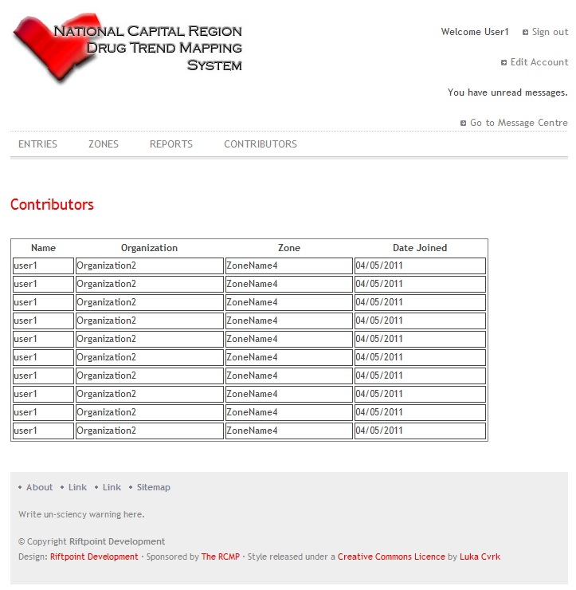

Figure 31 Contributor HCI

**Narrative:**

The Contributors Page shows the user the list of Contributors to the NCRDTMS in a DataGrid. It allows the data to be sorted by any of the fields. It also allows any Contributor in the Grid to be clicked to redirect to the Message Centre. Buttons appear for the administrator to edit Contributors' account details.

**Controls:**

* Each Contributor's name is a link to the Message Centre with that Contributor's name as a parameter.
* Each Header on the Datagrid is a button to change the sort order of the list of Contributors. This includes Name, Organization, Zones, and Date Joined. Each can be clicked once to sort by that field, and again to reverse sort.
  + 1. **Contributors Admin**

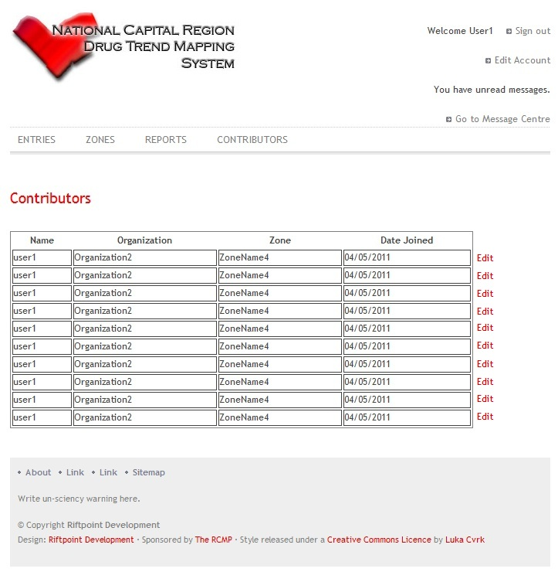

Figure 32 Contributors Administrator HCI

**Narrative:**

The following Contributors represent what an administrator will view. The View will Contributor page will change if an administrator is logged in.

**Controls:**

* An Edit button exists to the right of each record in the datagrid. It is enabled and displayed only to users logged in as administrators.
* This button redirects the administrator to the edit contributor page.
  + 1. **Edit Account**

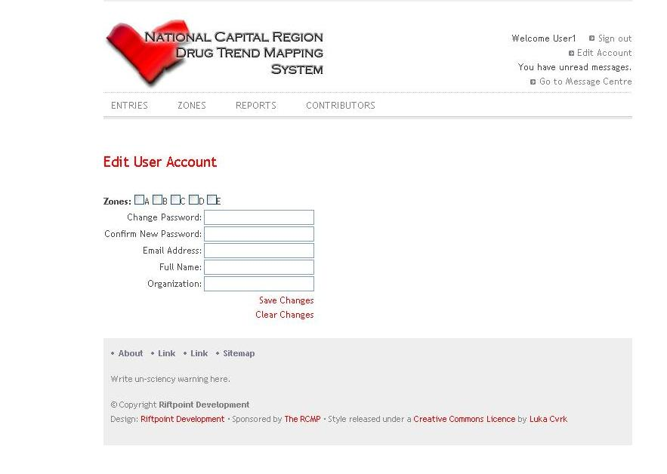

Figure 33 Edit Account HCI

**Narrative:**

The Edit Account Page allows an Administrator to edit the details of a particular user account. This includes adding or subtracting zone associations, giving a password reset, changing their active email address, name, and organization. The controls will be initialized with the current values of the Account in the database, except the password boxes, which are left empty.

**Controls:**

* Zone Checkboxes: A checkbox is displayed for each Zone in the System. Each box that is checked indicates a zone that the user being edited is associated with.Change
* Password: A textbox to enter a new password for this user if desired.
* Confirm Password: A second textbox to enter the new password for the user. If the text does not match that in the first box, an error will be generated.
* Email Address: A textbox to enter a new email address for the user.
* Full Name: A textbox to enter the name of the user.
* Organization: A textbox to enter the name of the Organization the Contributor works for.
* Save Changes: A button which submits any changes made to the user account to the database.
* Clear Changes: A button which resets the text in each box to the value currently stored in the database.
  + 1. **Edit Entry**

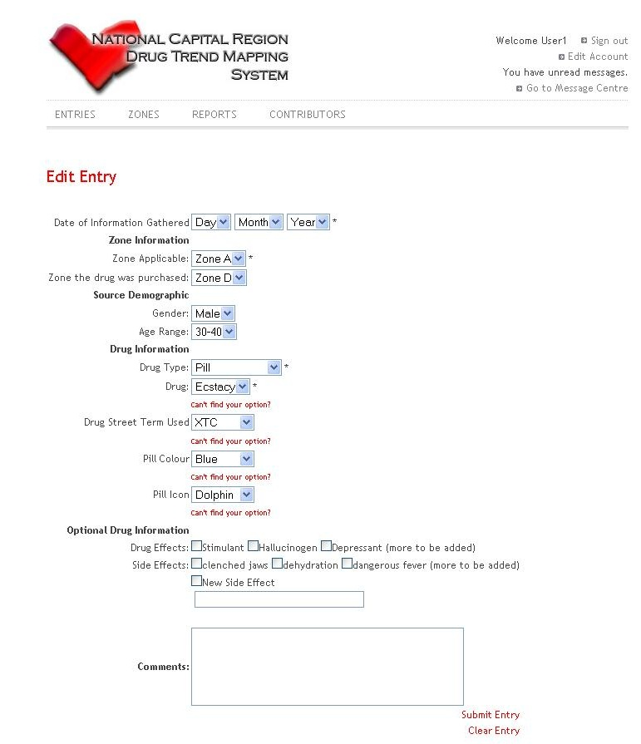

Figure 34 Edit Entry HCI

**Narrative:**

The Edit Entry Page allows an Administrator to edit the details of a particular Event Entry. This includes changing the date, zone of event, zone of purchase, source demographic gender and age range data, drug type, drug, drug alias, drug effects, side effects, and the applicable physical description fields. The controls will be initialized with the current values of the Entry in the database.

**Controls:**

* Date Gathered Dropdowns: Three dropdowns to select the day, month, and year of the event.
* Zone Applicable Dropdown: Dropdown menu to select the zone of the event
* Zone Purchased Dropdown: Dropdown menu to select the zone the drug was purchased in.
* Gender Dropdown: Dropdown menu to select the gender of the drug user.
* Age Range Dropdown: Dropdown menu to select the approximate age of the drug user.
* Drug Type Dropdown: Dropdown menu to select the type of drug reported.
* Drug Dropdown: Dropdown menu to select the drug reported.
* Add Category - Drug Link: Link to add a new drug to the list of possibilities.
* Drug Alias Dropdown: Dropdown menu to select the drug alias used.
* Add Category - Alias Link: Link to add a new alias to the list of possibilities.
* Pill Colour Dropdown: Dropdown menu to select the colour of the pill reported. It appears only if Pill is selected as the drug type.
* Add Category - Pill Colour: Link to add a new colour to the list of possibilities.
* Pill Stamp Dropdown: Dropdown menu to select the stamp of the pill reported. It appears only if Pill is selected as the drug type.
* Add Category - Pill Stamp: Link to add a new stamp to the list of possibilities.
* Drug Effects Checkboxes: A checkbox for each general drug effect listed in the database. The Administrator will check all that apply.
* New Effect Textbox: A textbox to fill in if the "New Effect" checkbox is checked.
* Drug Side Effects Checkboxes: A checkbox for each general drug side effect listed in the database. The Administrator will check all that apply.
* New Side Effect Textbox: A textbox to fill in if the "New Side Effect" checkbox is checked.
* Comments Textfield: A textfield to enter the comments to be attached to the entry.
* Submit Entry Button: Button to create the entry and submit it to the database.
* Clear Entry Button: Button to reset the other fields on the page to their default status.
  + 1. **Edit Settings**

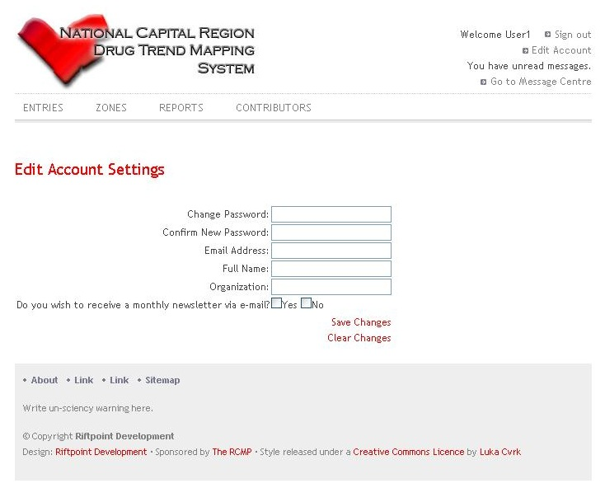

Figure 35 Edit Settings HCI

**Narrative:**

The Edit Account Page allows a User to edit the details of their own user account. This includes resetting the password, changing their active email address, name, and organization, and subscribing or unsubscribing from the monthly email newsletter. The controls will be initialized with the current values of the Account in the database, except the password boxes, which are left empty.

**Controls:**

* Change Password: A textbox to enter a new password for this user if desired.
* Confirm Password: A second textbox to enter the new password for the user. If the text does not match that in the first box, an error will be generated.
* Email Address: A textbox to enter a new email address for the user.
* Full Name: A textbox to enter the name of the user.
* Organization: A textbox to enter the name of the Organization the Contributor works for.
* Newsletter Checkboxes: A pair of checkboxes to select whether to receive the newsletter or not.
* Save Changes: A button which submits any changes made to the user account to the database.
* Clear Changes: A button which resets the text in each box to the value currently stored in the database.
  + 1. **Entries**

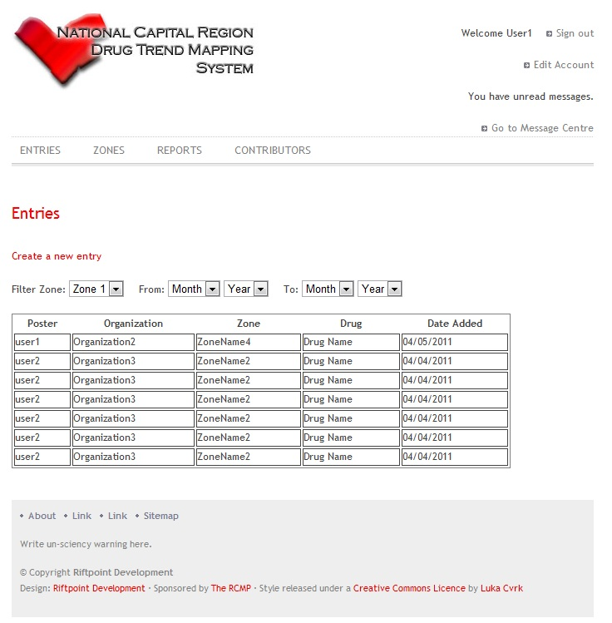

Figure 36 Entries HCI

**Narrative:**

The Entries Page shows the user the list of Event Entries to the NCRDTMS in a DataGrid. It allows the data to be sorted by any of the fields. Buttons appear for the administrator to edit Events' details.

**Controls:**

* Create Entry Button: Button that redirects the User to the Create Entry page.
* Filter Zone Dropdown: Dropdown list to select the zone to include entries from, or select all zones.
* From Date Dropdowns: Dropdown lists to select the starting month and year for entries to be shown.
* To Date Dropdowns: Dropdown lists to select the end month and year for entries to be shown.
* Each Header on the Datagrid is a button to change the sort order of the list of Event Entries. This includes Poster, Organization, Zone, Drug, and Date. The header can be clicked to sort by the field, and again to reverse sort.
  + 1. **Entries Admin**

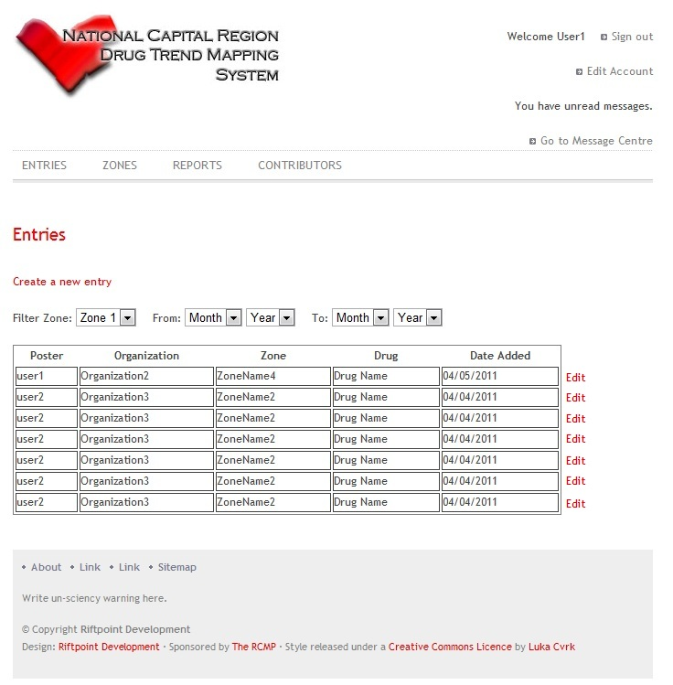

Figure 37 Entries Administrator HCI

**Narrative:**

The administrator has greater functionality then a regular user.

**Controls:**

* An Edit button exists to the right of each record in the datagrid. It is enabled and displayed only to users logged in as administrators. This button redirects the administrator to the edit event entry page.
  + 1. **Login**

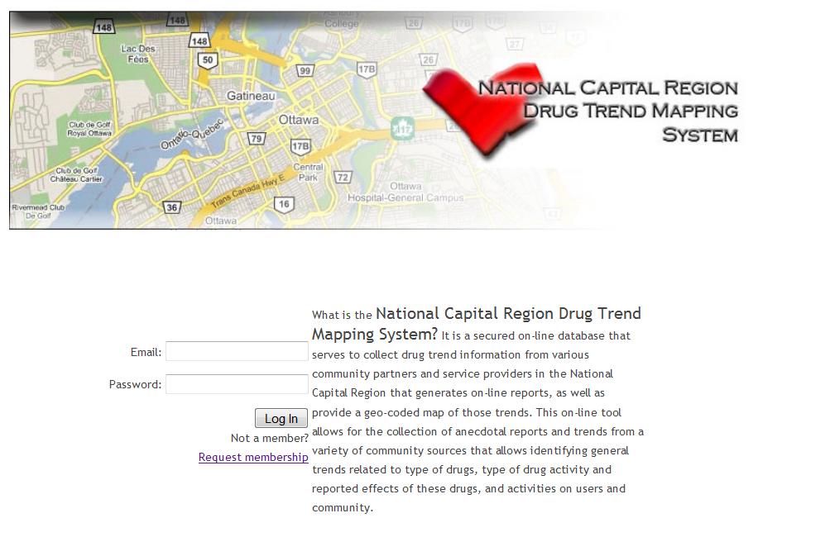

Figure 38 Login HCI

**Narrative:**

The Login Page allows the User to log on to the system or request membership. It also displays a description of the purpose of the NCRDTMS.

**Controls:**

* Email Textbox: Textbox to enter the email address of your user account.
* Password Textbox: Textbox to enter the password of your user account.
* Request Membership Link: Link to the Request Membership page.
  + 1. **Message Centre**

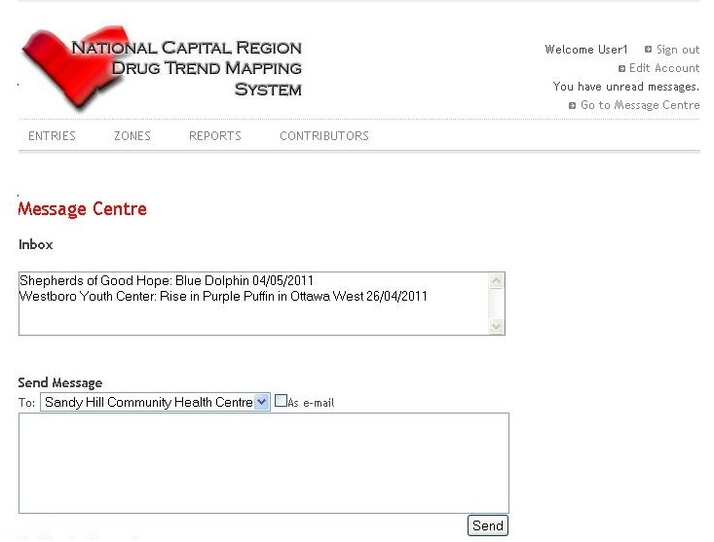

Figure 39 Message Centre HCI

**Narrative:**

The Message Centre allows the User to view the messages addressed to them or to all users. It also allows the User to compose a message and send it to another User or to all users.

**Controls:**

* Inbox List: A selectable list which displays the sender, first line, and date sent of each message addressed to the current user. When a message is selected in the list, its full text will appear in the Message Outputtext below.
* Message OutputText: An OutputText which will display the full text of the message that is selected in the inbox list.
* Message Recipient Dropdown: A dropdown to select the recipient of the new message being composed.
* As Email Checkbox: Checkbox to select to send an email notification to the recipient if the message is urgent.
* Message TextArea: Area to enter the full text of the message to be sent.
* Send Button: Button to submit the message to the database and send it to the recipient(s).
  + 1. **New Entry**



Figure 40 New Entry HCI

**Narrative:**

The New Entry Page allows a User to enter a new Event Entry. This includes entering the date, zone of event, zone of purchase, source demographic gender and age range data, drug type, drug, drug alias, drug effects, side effects, and the applicable physical description fields.

**Controls:**

* Date Gathered Dropdowns: Three dropdowns to select the day, month, and year of the event.
* Zone Applicable Dropdown: Dropdown menu to select the zone of the event.
* Zone Purchased Dropdown: Dropdown menu to select the zone the drug was purchased in.
* Gender Dropdown: Dropdown menu to select the gender of the drug user.
* Age Range Dropdown: Dropdown menu to select the approximate age of the drug user.
* Drug Type Dropdown: Dropdown menu to select the type of drug reported.
* Drug Dropdown: Dropdown menu to select the drug reported.
* Add Category - Drug Link: Link to add a new drug to the list of possibilities.
* Drug Alias Dropdown: Dropdown menu to select the drug alias used.
  + 1. **Report**

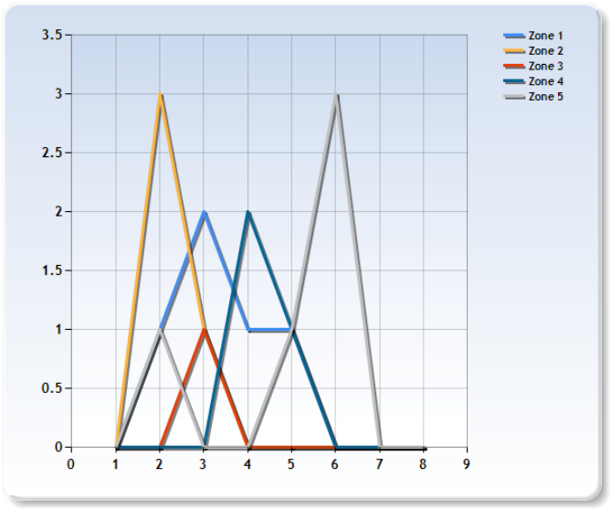

Figure 41 Report Preliminary HCI

**Narrative:**

The Report Page allows the user to generate reports based on the data stored in

the NCRDTMS database. It allows a report to be created based on a primary

comparison field selected by the user. The user may also filter the entries to

be used in composing the report by any of the fields in an Entry. The Report

Page also allows the user to load one of a set of pregenerated common report

parameters for ease of use. The page will include a small blurb explaining to

the user how to print the report or save it locally, along with a warning that

the data is not scientific.

**Controls:**

* Pregenerated Report Dropdown: a dropdown which generates and displays a report based on the report selected by the user.
* Chart List: A list which allows the user to choose a chart type.
* Primary Comparison Dropdown: A dropdown will allow the user to select a primary comparison field.
* More controls will exist to allow the user to select filters and additional options based on the chart type selected.
* A generate button will generate and display the chart when clicked
  + 1. **Request Membership**

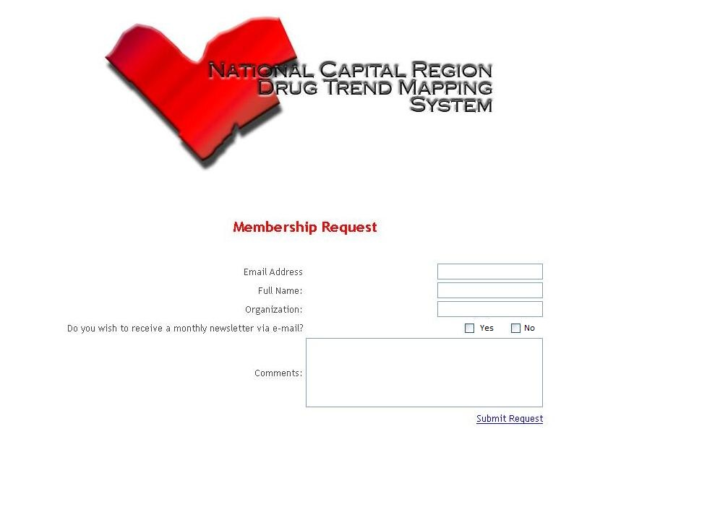

Figure 42 Request Membership HCI

**Narrative:**

The Request Membership Page allows a Potential User to enter the details of the user account they would like to create. This includes entering the email address, name, and organization, and subscribing or unsubscribing from the monthly email newsletter. The potential user can also fill in a field of comments that will be sent to the Owner with the account membership request.

**Controls:**

* Email Address: A textbox to enter the email address for the user.
* Full Name: A textbox to enter the name of the user.
* Organization: A textbox to enter the name of the Organization the Potential Contributor works for.
* Newsletter Checkboxes: A pair of checkboxes to select whether to receive the newsletter or not.
* Comments Field: A text area to enter any comments to be sent to the Owner with the membership request.
* Submit Request: A button which submits the requested user for the owner to approve or reject.
  + 1. **Welcome**

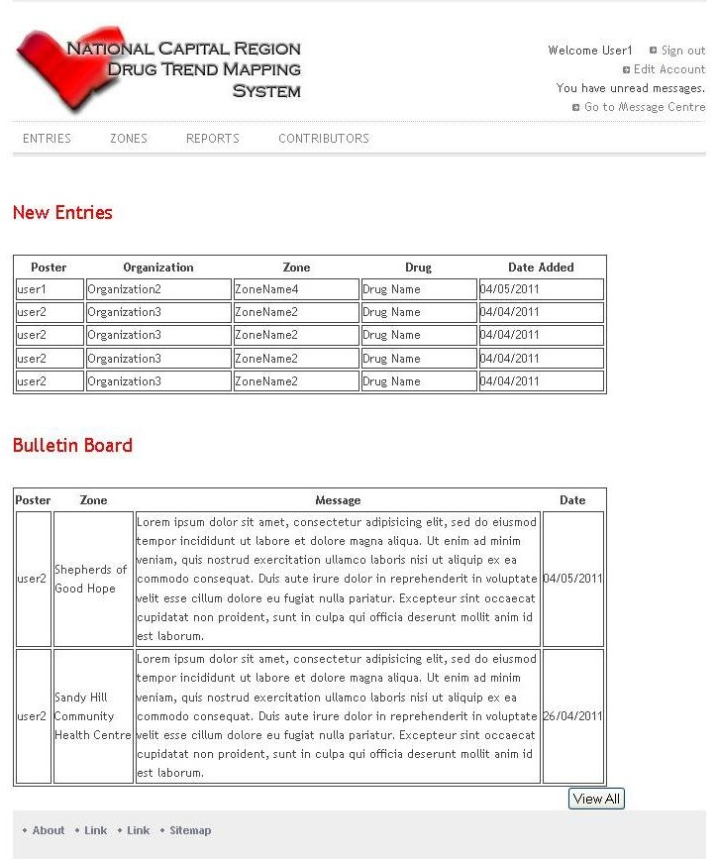

Figure 43 Welcome HCI

**Narrative**

The Welcome Page shows the user the list of Event Entries to the NCRDTMS and Messages addressed to them or to all posted since their last logon in a pair of DataGrids. It allows the Entries to be sorted by any of the fields. The messages are shown sorted by date.

**Controls:**

* Each Header on the Entries Datagrid is a button to change the sort order of the list of Event Entries. This includes Poster, Organization, Zone, Drug, and Date. The header can be clicked to sort by the field, and again to reverse sort.
  + 1. **Zones**

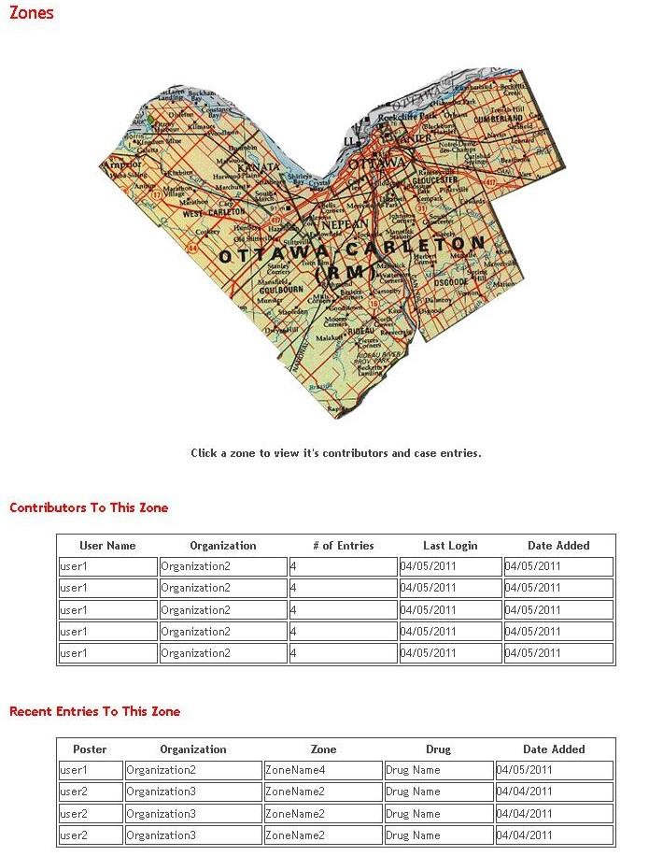

Figure 44 Zones HCI

**Narrative:**

The Zones Page shows the user the list of Zones on the NCRDTMS on a map. Each section of the map can be clicked to show the Conributors and Recent Entries to the Zone in a pair of DataGrids. Each allows the data to be sorted by any of the fields. The Contributors DataGrid also allows any Contributor in the Grid to be clicked to redirect to the Message Centre.

**Controls:**

* Each Contributor's name is a link to the Message Centre with that Contributor's name as a parameter.
* Each Header on the Contributors Datagrid is a button to change the sort order of the list of Contributors. This includes Name, Organization, Zones, and Date Joined. Each can be clicked once to sort by that field, and again to reverse sort.
* Each Header on the Entries Datagrid is a button to change the sort order of the list of Entries. This includes Poster, Organization, Zone, Drug, and Date Added. Each can be clicked once to sort by that field, and again to reverse sort.

1. **Restrictions Limitations and Constraints**

The Environment being used is a Windows Server R2 2008 with SQL Server Management Studio.

Once the Environment is setup we will load the database onto the server. We will all connect to the server with Visual Studio 2010 and load the database to generate the database management model, LINQ to SQL.